Laboratorio de Trunk-Based Development

Parte 1 — Guía paso a paso

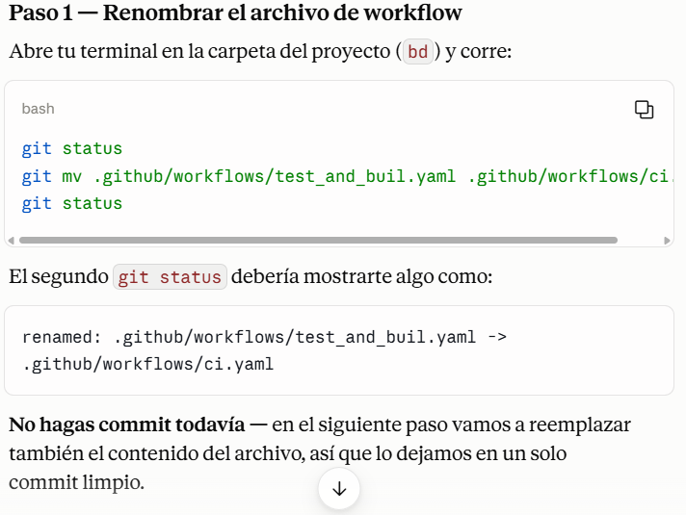

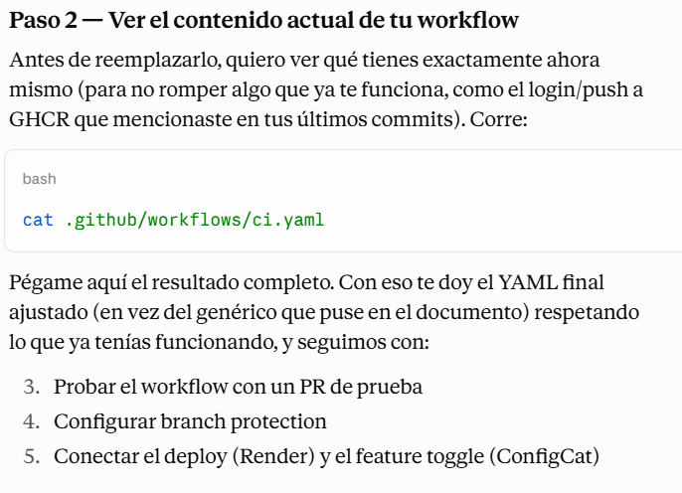

Les saldrá algo asi en terminal

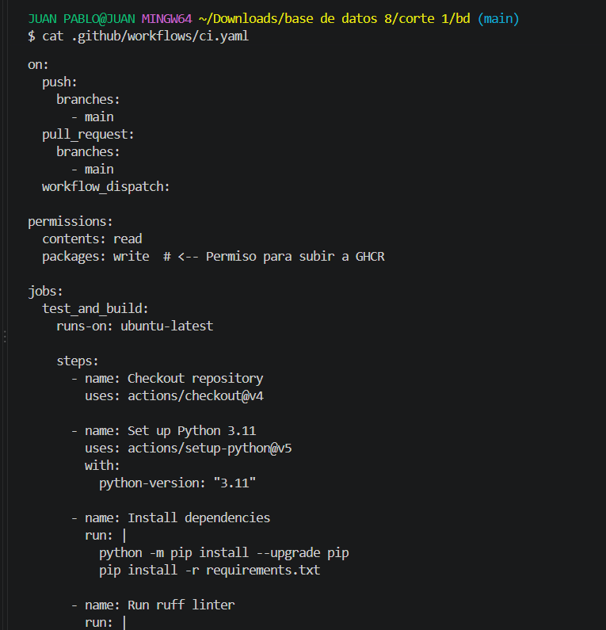

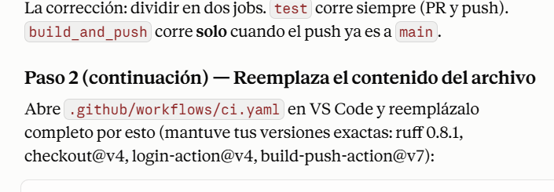

name: Test and Build

on:

push:

branches:

- main

pull_request:

branches:

- main

workflow_dispatch:

jobs:

test:

runs-on: ubuntu-latest

permissions:

contents: read

steps:

- name: Checkout repository

uses: actions/checkout@v4

- name: Set up Python 3.11

uses: actions/setup-python@v5

with:

python-version: "3.11"

- name: Install dependencies

run: |

python -m pip install --upgrade pip

pip install -r requirements.txt

- name: Run ruff linter

run: |

pip install ruff==0.8.1

ruff check .

- name: Run tests

run: |

pytest tests.py

build_and_push:

needs: test

if: github.ref == 'refs/heads/main' && github.event_name == 'push'

runs-on: ubuntu-latest

permissions:

contents: read

packages: write # <-- Permiso para subir a GHCR

steps:

- name: Checkout repository

uses: actions/checkout@v4

- name: Login to GitHub Container Registry

uses: docker/login-action@v4

with:

registry: ghcr.io

username: ${{ github.actor }}

password: ${{ secrets.GITHUB_TOKEN }}

- name: Build and push Docker image

uses: docker/build-push-action@v7

with:

context: .

push: true

tags: ghcr.io/${{ github.repository }}:latest

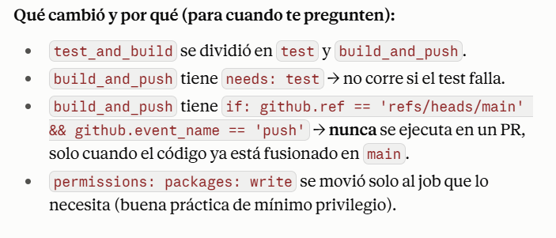

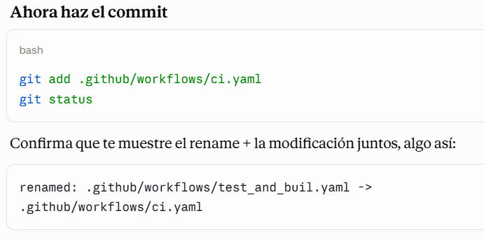

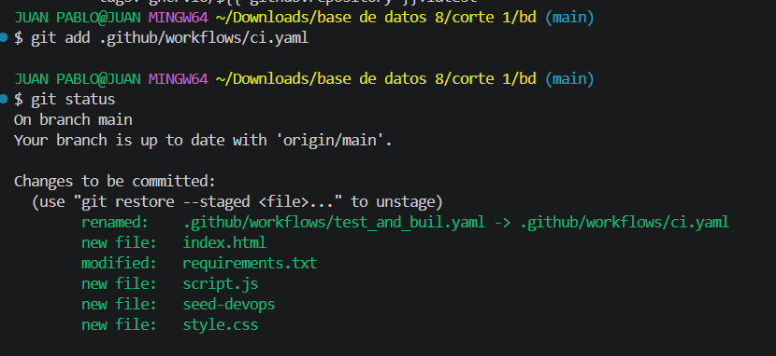

Luego:

bash

git commit -m "refactor(ci): separar job de test y build_and_push; build_and_push solo corre en push a main"

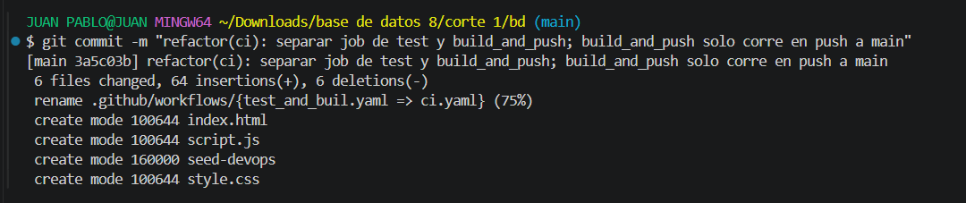

git push origin main

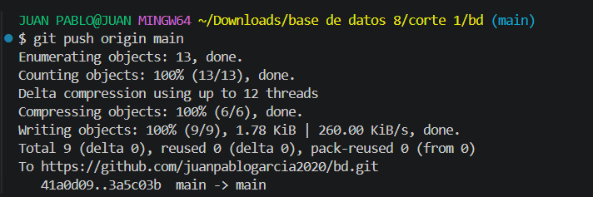

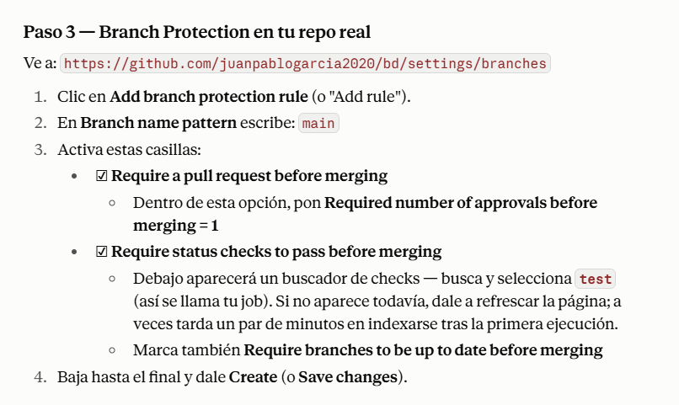

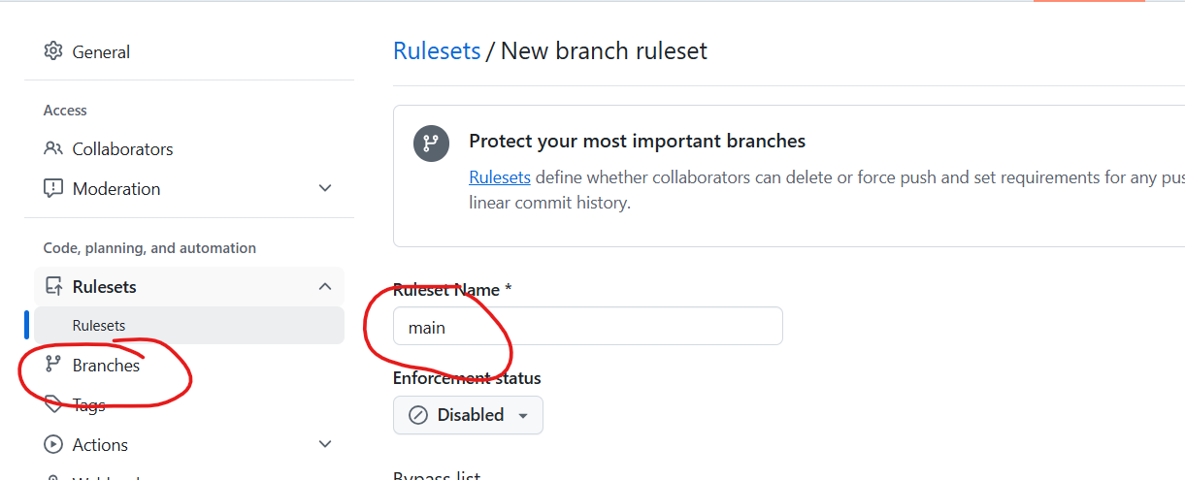

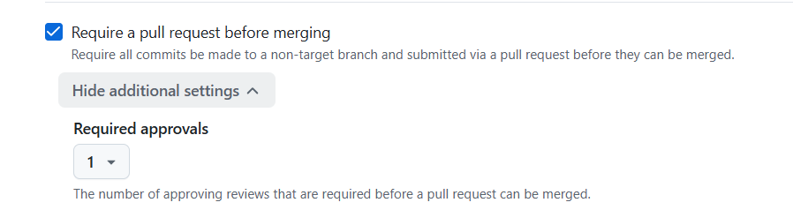

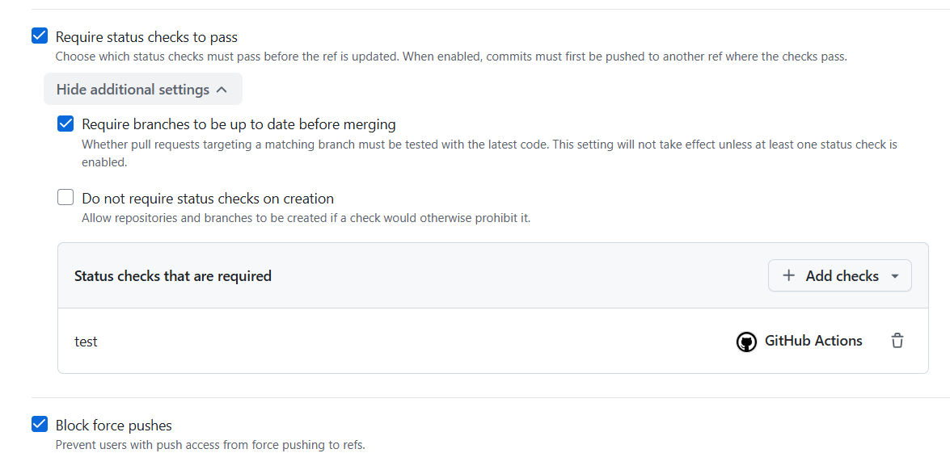

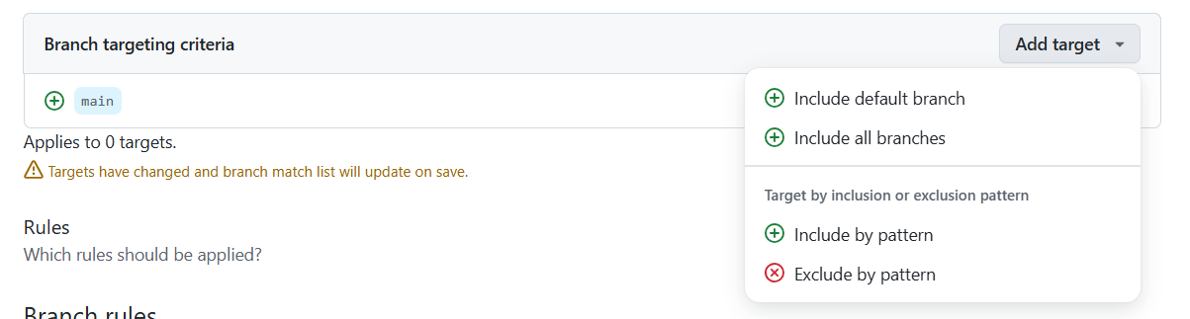

Include default brach: acepta por defecto a mian

Include by patthern main

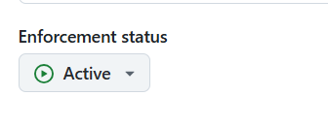

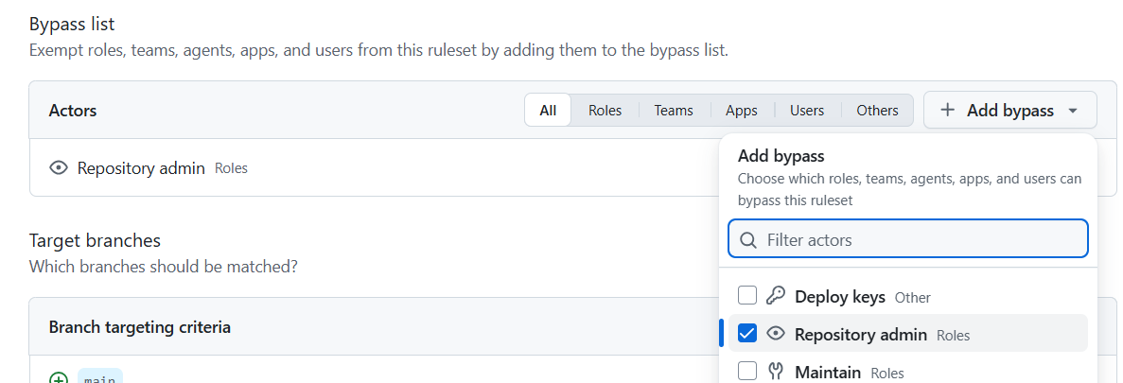

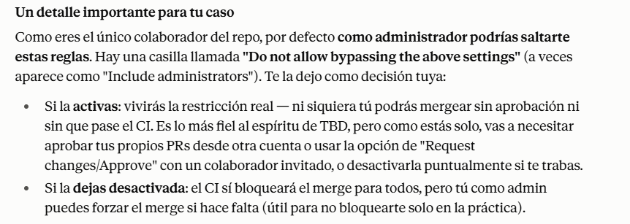

Les debe dar un mensaje de alerta así

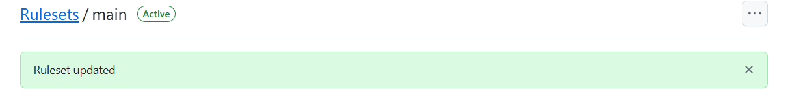

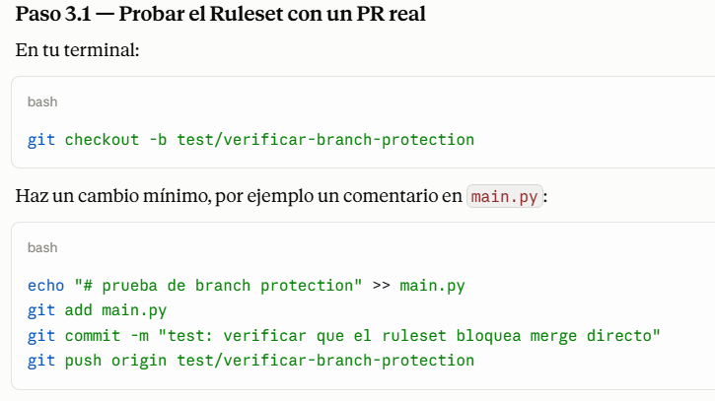

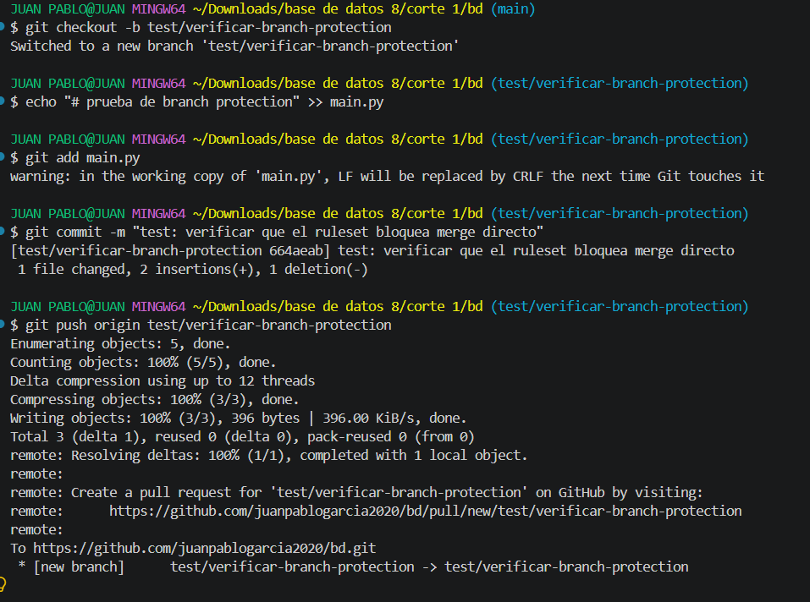

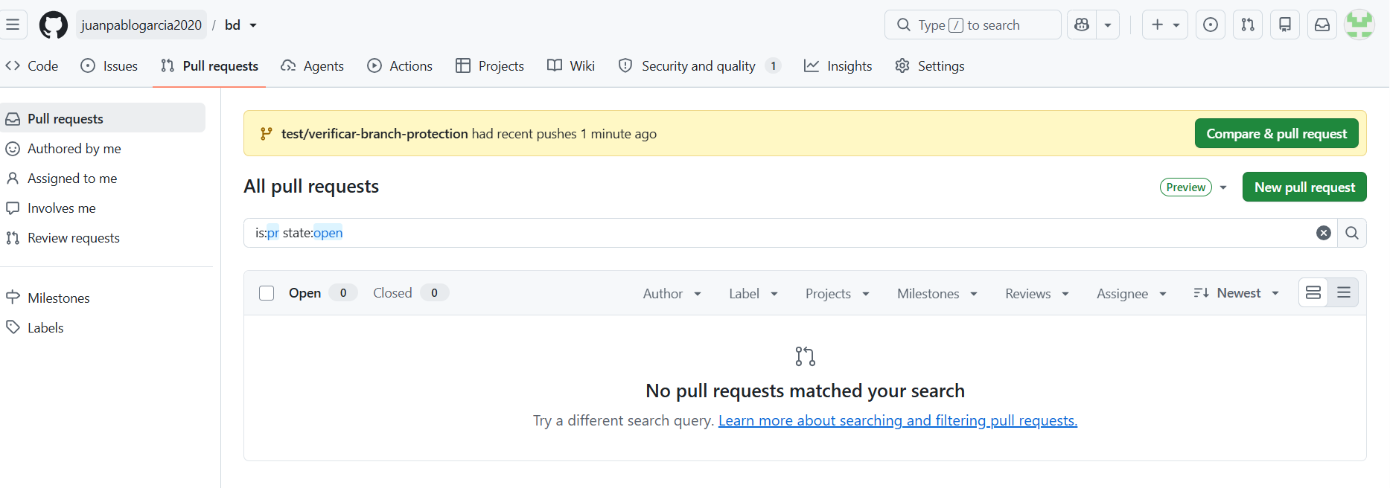

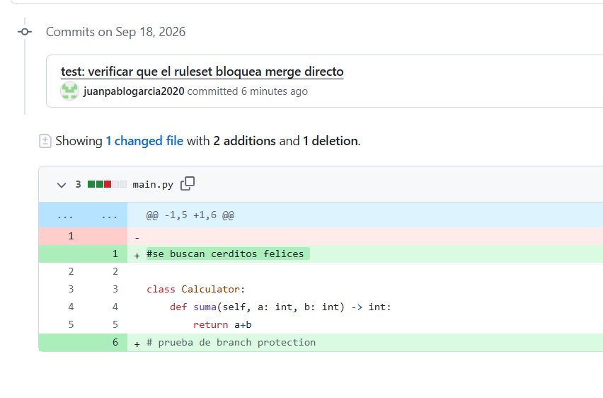

Darle click al botón Create pull request

